Wedding Sand Art Video Order Form
(Please use the content as sample, and replace with your own information)
All content should be filled! Date：

Contact Name |  | Address:
Mobile |  | Email address
Groom’s name |  | Groom’s Feature | e.g. wearing glasses
Bride’s name |  | Bride’s Feature | e.g. short hair, long hair
Wedding Date |  | No. of scenes | 8+1(the additional scene is free of charge)

Attach picture if you want:
Time | 1min/scene | Background voice | Please provide mp3 file and attach it in the email
Script 01 | Subtitle to be put on the scene：In October 2011, we walked into each others’ lives. I did not know that we would start a relationship, but what I knew is every time I see your face, it lights up my world.
Scene content：Two people walk towards each other in front of the Durham Cathedral
Write “Durham, Oct. 2011” with sand.
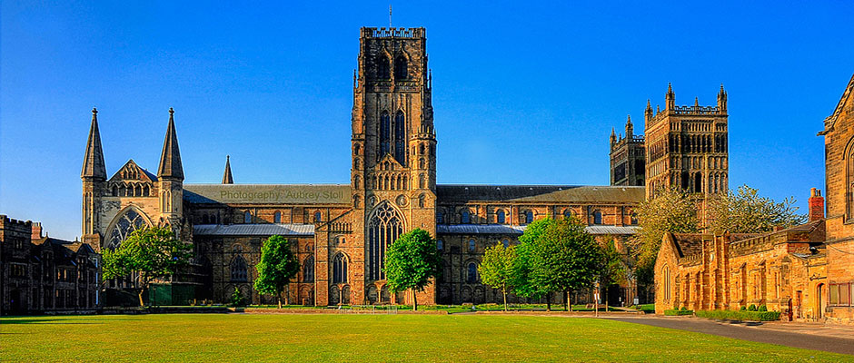
Script 02 | Subtitle to be put on the scene：Remember the time you taught me how to make snow angel?
Scene content：The boy teaches the girl how to make snow angel.
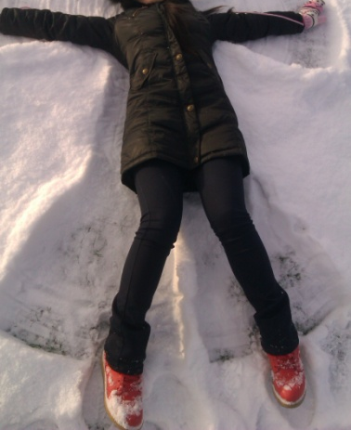
Script 03 | Subtitle to be put on the scene：Time seemed to go by so quickly, and soon we had finished our degrees.
Scene content：Graduation ceremony at Durham Cathedral.
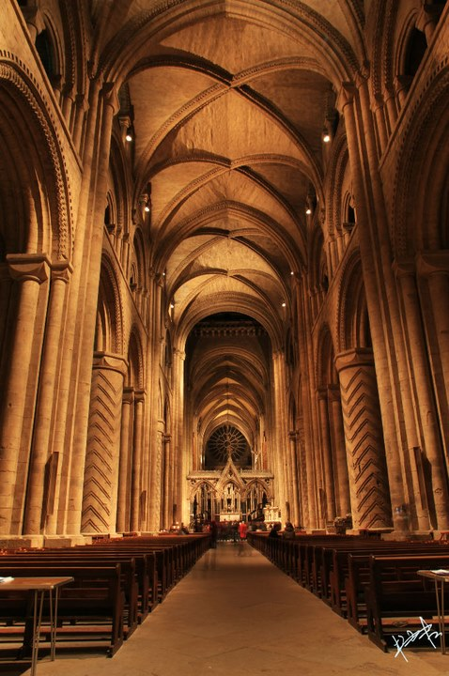
Script 04 | Subtitle to be put on the scene：Being apart for 4 year! 5080 miles! That is the physical distance between us. Luckily, the distance between our hearts is 0 mile.
Scene content：Divide this scenery into 2 scenes. On the left hand side, the boy works in Newcastle (with Millennium bridge as background, write “UK” with sand); on the right hand side, the girl works in China (write “China” with sand).
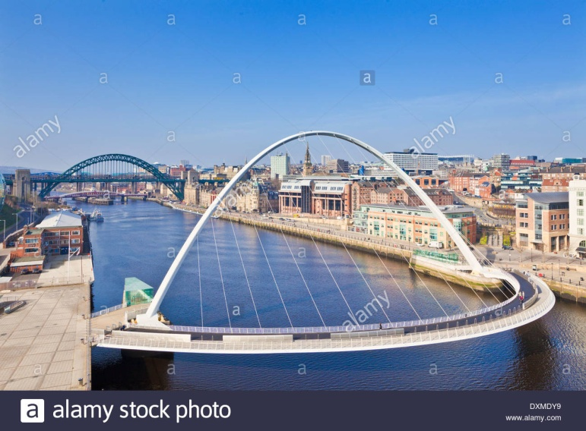
Script 05 | Subtitle to be put on the scene：Since then, airport becomes a place which I LOVE and HATE most.
 | Scene content：At the airport, there are two couples. For one couple, they are reunion, for the other couple, they are separating.
Script 06 | Subtitle to be put on the scene：Finally, this time I only need to buy a one-way ticket! I feel safe and protected when I am around you. My dreams come true because of you.
Scene content：Use the Angel of the North to express that I feel protected when I am with him.
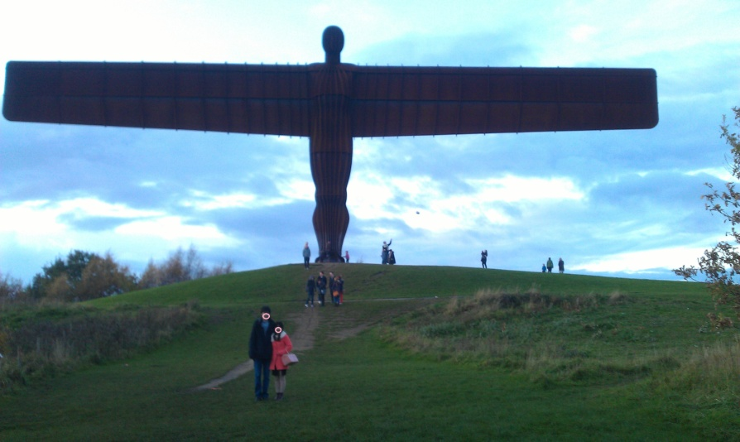
脚本07 | Subtitle to be put on the scene：People say that if you kiss the person you love at the top of London Eye, you will spend the rest of your life together. So we did.
 | Scene content：Two person kiss at London Eye
Script 08 | Subtitle to be put on the scene：Right beside you is where I belong  I give my hand to you with all my heart  Can't wait to live my life with you, can't wait to start
 | Scene content：The wedding day.
Script 09 | Subtitle to be put on the scene：From this moment life has begun  From this moment you are the one  I will love you as long as I live  From this moment on...
 | Scene content：Two person hand in hand and face the future
Please send this order form along with voice mp3 file to info@havingapartylimited.co.uk

